**Jabber Chat Archiver and Explorer**

Getting Started:

* Deflate the zip file “JabberChatArchiver.” To C:\jabberSync\
* Before you start using the application few one time configuration needs to be done.
* Start jabber.exe from the location C:\jabberSync\jabber\jabber.exe 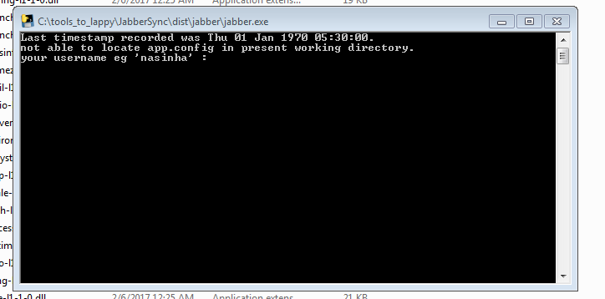
* Enter your username **DO NOT** append organization address ie @informatica.com

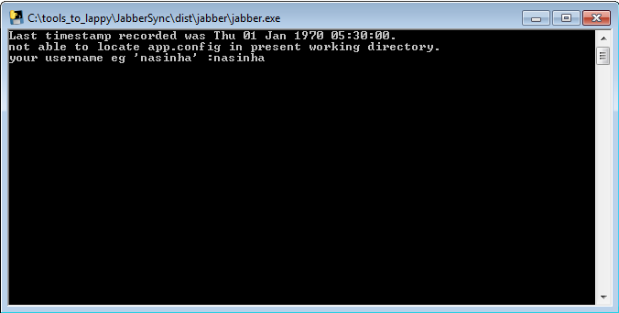

* The application will by itself find the jabber database location, provide your confirmation.

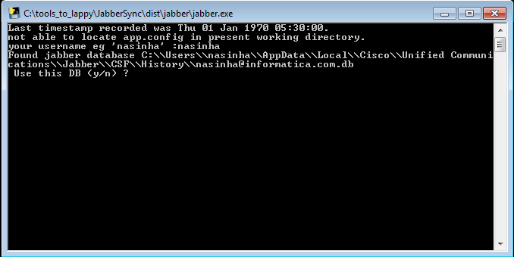

* After this the application will save the configuration to the temporary files and will use it in subsequent runs.
* Once this is done you should be able to view your chats in “C:\jabberSync\jabber\database” directory
* s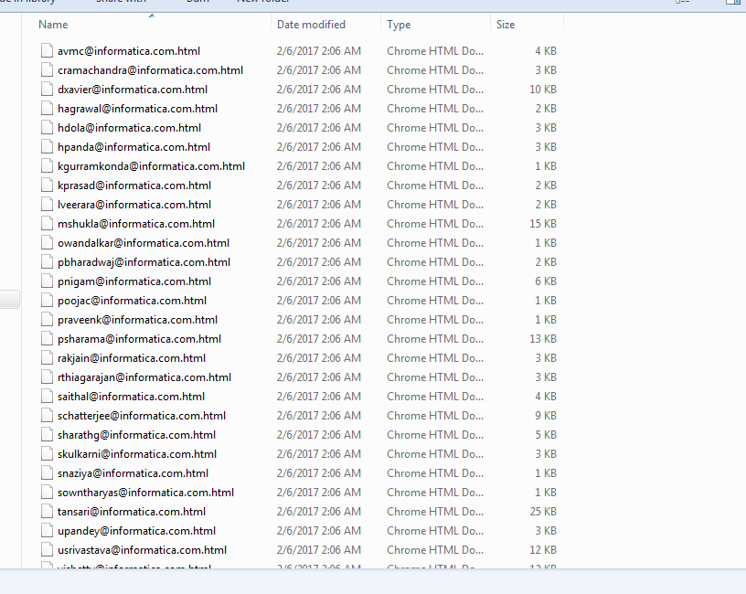

**Schedule Jabber Chat Archiver to automatically backup chats**

* Open windows task scheduler, type “scheduler” in search

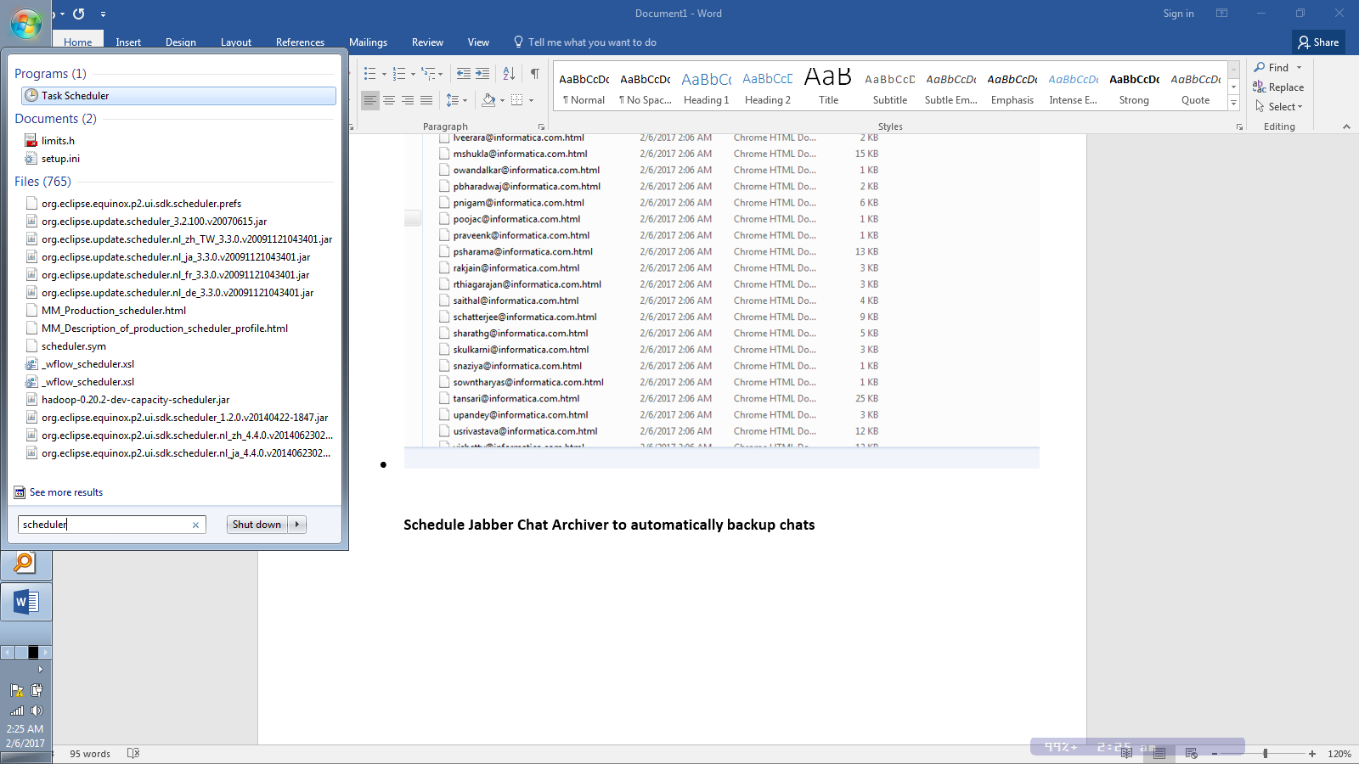

* If you have used the location “C:\jabberSync\jabber\” Click on import task or use create basic task option to create a new task.
* You will find “jabber.xml” in the files deflated.
* 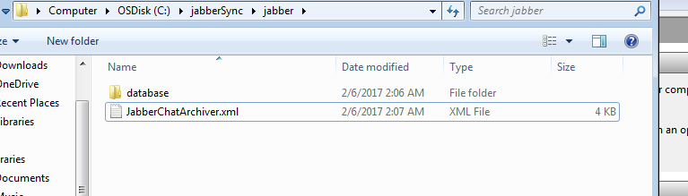
* After importing this file, you should see the following window
* 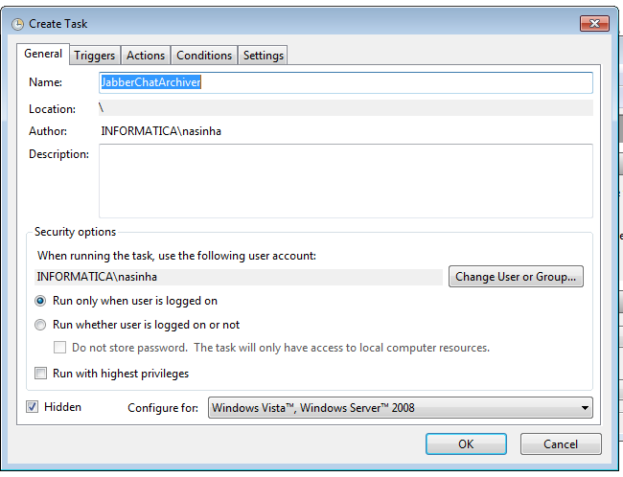
* Go to Actions and double click on “start a program”
* 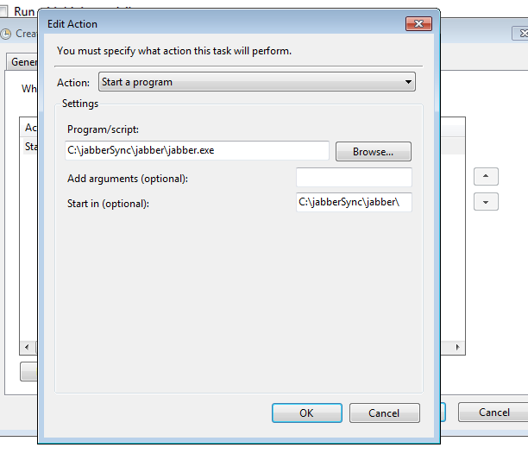
* Verify the links, “Start in” should point to “C:\jabberSync\jabber\”
* Click on ok and save the task.
* Now the application should start automatically at regular intervals and backup your chats.